A

Project Report

On

**“MACFUTSAL”**



*Submitted in Partial Fulfillment of the Requirement for Degree of Bachelor of Science in Computer Science and Information Technology (B. Sc. CSIT) Awarded by Tribhuvan University*

**Submitted by:**

Binay Adhikari [21828/075]

Mabisha Koirala [21833/075]

Ramesh B.K [21838/075]

**Under Supervision of:**

Er. Bhesh Bahadur Thapa



##### DEPARTMENT OF COMPUTER SCIENCE AND

##### INFORMATION TECHNOLOGY

**Mount Annapurna Campus**

**Pokhara-05, Parshyang**

MAY, 2023



**Tribhuvan University**

**Institute of Science and Technology**

**Mount Annapurna Campus, Parshyang-05, Pokhara, kaski**

**Student's Declaration**

We hereby declare that we are only author of this project work and that no sources other than listed here have been used in this work.

1. Binay Adhikari (21828/075)…………………………….
2. Mabisha Koirala (21833/075)…………………………...
3. Ramesh B.K (21840/075)………………………………

**Mount Annapurna Campus, Parshyang-05, Pokhara**

**B.Sc. CSIT Department**



**Tribhuvan University**

**Institute of Science and Technology**

**Mount Annapurna Campus, Parshyang-05, Pokhara, kaski**

**Supervisor's Recommendation**

I hereby recommend that the project work prepared under my supervision by below listed team of students entitled "**MacFutsal"** be accepted as in fulfilling partial requirement for completion of Four Year's Bachelor's Degree in Computer Science and Information Technology. In my best knowledge this is an original work in Computer Science and Information Technology.

1. Binay Adhikari (21828/075)
2. Mabisha Koirala (21833/075)
3. Ramesh B.K (21840/075)

…………………………..

**Er. Bhesh Bahadur Thapa**

B. Sc. CSIT Department

Mount Annapurna Campus, Pokhara



**Tribhuvan University**

**Institute of Science and Technology**

**Mount Annapurna Campus, Pokhara-05, Parshyang , kaski**

**LETTER OF APPROVAL**

We certify that we have read this project work report and, in our opinion, it is appreciable for the scope and quality as a project work in the partial fulfillment of the requirements of Four Years Bachelor Degree of Science in Computer Science and Information Technology.

**Evaluation Committee**

__________ _________________ ______________________________

**Surya Bahadur G.C Er. Bhesh Bahadur Thapa**

(Campus Director) (Supervisor)

B. Sc. CSIT Department B. Sc. CSIT Department

Mount Annapurna Campus Mount Annapurna Campus,

______________________

**Prithivi Raj Paneru**

(External Examiner)

Central Department of Computer Science & Information Technology

Tribhuvan University

# ACKNOWLEDGMENT

First of all, we would like to thank Tribhuvan University for providing us an opportunity to apply academic knowledge under supervised hands of field conditions.

We would like to express our sincere gratitude to our project supervisor and our program coordinator Er. Bhesh Bahadur Thapa for his valuable guidance and encouragement, coordination and support related to this project throughout this project work. This project bears an imprint of many people. We also like to express our gratitude to the officials and other staff members of Mount Annapurna Campus B. Sc. CSIT who rendered their help during the period of our project.

We fall short of words to pen down anything for the co-operation and encouragement extended by our project group members through the completion of this project.

Binay Adhikari [21828/075]

Mabisha Koirala [21833/075]

Ramesh B.K [21838/075]

# ABSTRACT

This project has been developed to fulfill the registered course, "Project for the Bachelor Degree of Computer Science and Information Technology in Tribhuvan University". It has been submitted to BSC.CSIT department of Mount Annapurna Campus.

The work presented in this report involved developing a MacFutsal application. MacFutsal is a web based application designed to simplify the management of Futsal court, booking and player registration. This system uses the Python Programming Language. The purpose of designing this system is to make it easier for users to do field management using computerized media. MacFutsal is expected to facilitate the parts involved in data processing, scheduling and member registration or students. The system uses a database to store all relevant information, including court availability, bookings and player profile and provides intuitive user interface for easy navigation. With the MacFutsal, students and college administration can efficiently manage their activities and ensure a hassle-free futsal experience.

***Keywords:*** *Management, Futsal, booking futsal field, Web, Python, django.*

Table of Contents

ACKNOWLEDGMENT i

ABSTRACT ii

List of Abbreviations vi

List of Figure vii

List of Table viii

INTRODUCTION 1

1.1 Background 1

1.2 Problem statement 1

1.3 Objective 2

1.4 Scope and Limitation 2

1.4.1 Scope 2

1.5 Development Methodology 3

1.5.1 Agile Model 3

1.6 Report Organization 4

LITERATURE REVIEW 6

2.1 Content review 6

2.2 Related works 7

REQUIREMENT STUDY AND ANALYSIS 8

3.1 Requirement Analysis 8

3.1.1 Functional Requirements 8

3.1.2 Non-Functional Requirement 9

3.2 Feasibility Study 10

3.2.1 Technical Feasibility 10

3.2.2 Operational Feasibility 10

3.2.3 Economic Feasibility 10

3.2.4 Schedule Feasibility 10

3.3 System Requirements 11

3.3.1 Hardware Requirements 11

3.3.2 Software Requirements 11

3.4 Analysis 12

3.4.1 Class and object diagram 12

3.4.2 Sequence Diagram 13

3.4.3 Activity Diagram 15

3.5 Use Case Diagram 17

3.5.1 Use Case Diagram for User, Admin 17

3.5.2 Use Case Diagram for Class coordinator and Game manager 19

SYSTEM DESIGN 20

4.1 Database Design 20

4.1.1 Database Table for Admin 20

4.1.2 Database Table for User 20

4.1.3 Database Table for Game Announcement 22

4.1.4 Database Table for Futsal Game 22

4.1.5 Database Table for Player Score 23

4.1.6 Database Table for Teams 23

4.1.7 Database Table for Team Members 24

4.2 Component Diagram 24

4.3 Deployment Diagram 25

4.4 Overall Flow Diagram 27

IMPLEMENTATION AND TESTING 28

5.1 Implementation 28

5.1.1. Tools/Libraries Used 28

5.2 Testing Approaches 30

5.2.1 Unit Testing 30

5.2.2 Stress Testing 32

5.2.3 Actual system Testing 32

5.2.4 Functional Testing 32

5.2.5 System Testing 32

5.2.6 Acceptance Testing 33

5.3 Outcomes 33

MAINTENANCE AND SUPPORT 34

6.1 Corrective maintenance 34

6.2 Adaptive maintenance 34

6.3 Preventive maintenance 35

6.4 Perfective maintenance 35

CONCLUSION AND FUTURE RECOMMENDATIONS 36

7.1. Conclusion 36

7.2 Limitations of the System 36

7.3 Future Enhancements 37

REFERENCES 38

APPENDIX 40

9.1 Screenshots 40

# List of Abbreviations

|  |  |
| --- | --- |
| CSS | Cascading Style Sheet |
| HTML | Hypertext Markup Language |
| IDE | Integrated Development Environment |
| JS | JavaScript |
| QA | Quality Assurance |
| URL | Uniform Resource Locator |
| VS Code | Visual Studio Code |
| CR | Class Coordinator |
| GM | Game Manager |

# List of Figure

Figure 1 : Agile Model 4

Figure 2 : Gantt chart for Working Schedule 11

Figure 3 : Class and Object Diagram 13

Figure 4 : Sequence Diagram 14

Figure 5 : Activity Diagram 16

Figure 6 : Use case diagram for user 17

Figure 7 : Use case diagram for Admin 18

Figure 8 : Use case diagram for Class coordinator and Game Manager 19

Figure 9 : Component Diagram 25

Figure 10 : Deployment Diagram 26

# List of Table

Table 1 : Database Table for Admin 20

Table 2 : Database table for user 20

Table 3 : Database table for Game Announcement 22

Table 4 : Database table for Futsal Game 22

Table 5 : Database table for Player score 23

Table 6 : Database table for Teams 23

Table 7 : Database table for Team Members 24

Table 8 : User Login 30

Table 9 : User Registration 31

Table 10 : Result of Few Testing 32

**CHAPTER** **1**

# INTRODUCTION

## 1.1 Background

The MacFutsal application is a college Futsal management system designed to streamline the process of organizing and managing futsal tournaments for colleges. Futsal is a popular sport played worldwide and is gaining popularity in colleges as well. However, organizing and managing a futsal tournament can be a challenging task, especially for colleges that lack dedicated staff for sports management. The MacFutsal application aims to address this challenge by providing a platform for colleges to manage their futsal tournaments efficiently. The MacFutsal application allows college admins to create and announce futsal tournaments and invite students to participate. Students can then apply for the role of Class Coordinator or Game Manager, which enables them to manage and organize the tournament. Class Coordinators are responsible for registering the teams of their batches, while Game Managers can update news and results of completed games. This system ensures that the tournament is organized smoothly, and all necessary information is available in one place.

Overall, the MacFutsal application simplifies the process of managing futsal tournaments for colleges, allowing them to focus on providing an excellent experience for their participants.

## 1.2 Problem statement

The problem statement is that there is a need for an efficient and automated futsal management system for colleges and institutions. The current manual processes for booking games, managing teams, and creating schedules can lead to errors, delays and a poor user experience for players and teams. The aim of this project is to develop a comprehensive futsal management system that can automate and streamline the various processes involved in managing a futsal facility, leading to improved efficiency and reduced errors. The system will allow users to register, apply for roles such as class coordinators and game managers, and manage their teams for tournaments. Additionally, the system will record and track game results, generate reports, and provide updated statistics for tournaments. The ultimate goal of this project is to provide an enhanced user experience for all students involved in futsal tournaments and activities.

## 1.3 Objective

The main aim of this project is to design, develop a system via online which would assist the players who love to play futsal and to digitize the manual workload for creating a games.

The overall objective of the system includes:

* To automate the process of managing futsal tournaments and scheduling games, this will reduce errors and increase efficiency.
* To make a triparty (college,students,futsal) communication for effective extra curriculum management especially futsal.

## 1.4 Scope and Limitation

### 1.4.1 Scope

The scope of a futsal management system can be quite broad, depending on the specific needs of the organization or facility. Generally, a futsal management system is designed to help manage and streamline the various aspects of operating a futsal facility or organizing futsal events.

Some of the key features that may be included in a futsal management system could include:

* **Facility management:** This could include features like court booking management, equipment management, and maintenance scheduling.
* **Player registration and management**: A futsal management system could provide tools to manage player registration, track player attendance and performance, and communicate with players.
* **League and tournament management:** A system could help manage scheduling, game results and standings, as well as communicate with teams and officials.
* **Communication**: A futsal management system could provide a platform for communicating with players, coaches, officials, and other stakeholders, as well as providing tools for marketing and promoting the facility or events.

## 1.5 Development Methodology

### 1.5.1 Agile Model

In our project, the agile methodology seems to be more appropriate when it comes to frequent requirement changes. In MacFutsal , agile methodology can be used to improve the team's performance, communication, and adaptability. We don’t have to wait for the process to end and repeat the activity to the end. Since the Agile methodology includes every aspect of software development, there will be separate activities for testing, and evaluating the requirements, and the project outcomes.

Here are some steps that could be taken to implement agile methodology in our project:

* **Define the project goals and scope**: In MacFutsal, the goals and scope of the project are clearly define, including the features and functions that the system will need to have.
* **Plan and prioritize**:In this phase,we Plan and prioritize the features that will be developed in each iteration, based on the most important and high-priority requirements.
* **Develop in iterations**:The project has been developed the system in iterations, with each iteration lasting 1-2 weeks. Each iteration should focus on developing a small set of features.
* **Regularly review and adjust**: We regularly review the progress made in each iteration, get feedback from users,supervisor and adjust the plan and priorities as needed.
* **Collaborate and communicate**:In this phase, Team members communicate with the stakeholders throughout the development process.
* **Test and validate**: We have test each iteration of the system with our supervisor to ensure that it meets the requirements and works as intended.

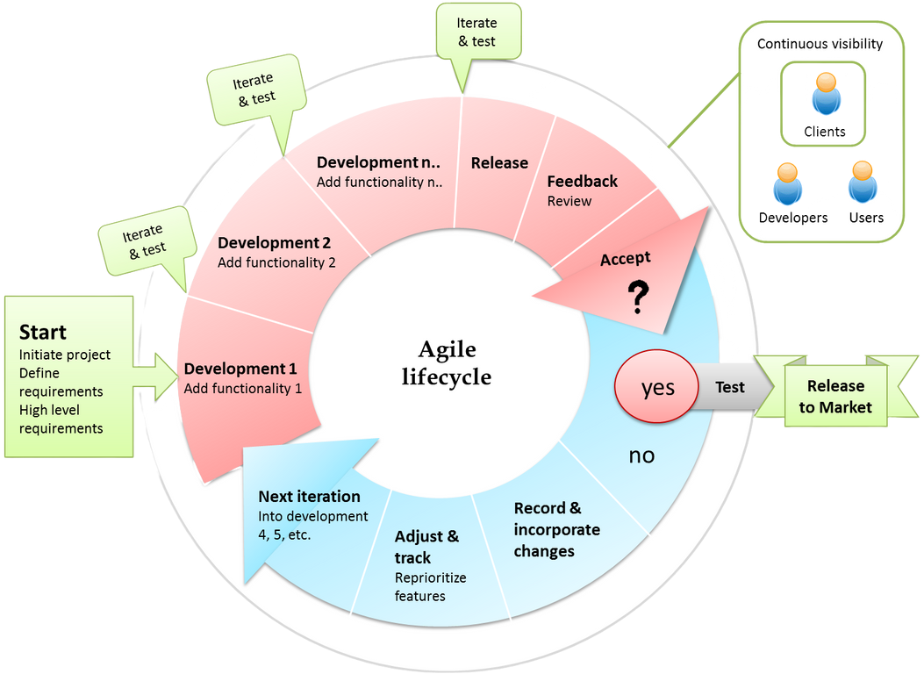

**Figure 1****: Agile Model**

## 1.6 Report Organization

A report on the organization of a futsal management system should provide a detailed and comprehensive overview of the system, including its Introduction, System design, implementation, and evaluation. It should also highlight the specific requirements of the system's users and provide recommendations for future improvements.

A report organization for a futsal management system could be structured as follows:

* **Introduction:** This section should provide a brief overview of the futsal management system, its purpose and key features it offers.
* **System Overview:** In this section you should describe the systems architecture ,including its components, how they work together to achieve the system’s objectives.
* **User Requirements**: Here, we should outline the requirements of the system’s users including players, manager, class coordinator and Administrators .This section should also address any potential conflict or issues that may arise from the different requirements of these groups.
* **Functional Requirements**: This section should detail the features and functions of the MacFutsal including player registration, team management, game scheduling, scoring and statistics , and other key features.
* **Technical Requirements** : Here ,we should specify the technical requirements of the system, including hardware and software specifications, network requirements, and any other technical consideration that need to be addressed.
* **Implementation Plan :** In this section ,we should outline the steps required to implement the futsal management system , including project management, system design, development ,testing ,deployment and maintenance .
* **Testing and Validation :** Here, we should outline the testing and validation process for the futsal management system, including how the system will be tested, the criteria for success ,and how any issue or bugs will be addressed.
* **Conclusion:** This section summarizes the key points of the report and highlights the benefits of the futsal management system, both for the organization and its users. It should also identify any future opportunities for system enhancement or expansion.

**CHAPTER 2**

# LITERATURE REVIEW

## 2.1 Content review

The use of technology has revolutionized sports management, including the management of futsal tournaments. Futsal is a fast-growing sport in many countries, and managing futsal leagues and tournaments can be a challenging task for college administrators. One solution to streamline futsal management is to develop a futsal management system that can handle tasks such as scheduling, team registration, score reporting, and communication.

Several studies have been conducted to explore the feasibility and effectiveness of futsal management systems.

Study by Al-Radaideh et al. (2018) developed a futsal management system that allowed the registration of teams, the creation of fixtures, the management of scores, and the generation of reports. The system was implemented in a Jordanian university, improving the organization and management of futsal tournaments and reducing the workload of administrators. [2]

In a study conducted by Ahmad et al. (2019), a futsal management system was developed and implemented in a Malaysian university. The system was found to significantly improve the efficiency and effectiveness of futsal management, with positive feedback from both administrators and players.[3]

Similarly, a study by Akyol et al. (2020) developed a futsal management system for a Turkish university and found that it improved the management of futsal tournaments and reduced the workload of administrators.[4]

Another study by Raju et al. (2021) developed a futsal management system for a college in India, which included features such as player registration, team management, fixture creation, score management, and league tables. The system was found to be effective in managing futsal tournaments and received positive feedback from users.[8]

Overall, these studies suggest that futsal management systems can be a valuable tool for college administrators to manage futsal leagues and tournaments. The systems can improve efficiency, reduce workload, and provide a better user experience for players and administrators.

MacFutsal is developed to introduce a new futsal management system to any organization, Schools, colleges and Universities in order to improve the efficiency and effectiveness of existing Extra curriculum events and to provide a better experience for the students, players and other stakeholders.

## Related works

* **Matchapp:** Matchapp is a web-based platform that provides features for managing futsal tournaments, including team registration, fixture creation, score management, and league tables. The platform also provides a mobile app for players and administrators to access the system on-the-go.[11]
* **SportEasy:** SportEasy is a sports management platform that provides features for managing futsal tournaments, including team registration, fixture creation, score management, and communication with players and administrators. The platform also provides a mobile app for players and administrators to access the system on-the-go.[13]
* **Scorebook:** Scorebook is a sports management platform that provides features for managing futsal tournaments, including team registration, fixture creation, score management, and league tables. The platform also provides a mobile app for players and administrators to access the system on-the-go.[12]
* **Team Snap**: Team Snap is a sports management platform that provides features for managing futsal tournaments, including team registration, fixture creation, score management, and communication with players and administrators. The platform also provides a mobile app for players and administrators to access the system on-the-go.[10]

**Chapter 3**

# REQUIREMENT STUDY AND ANALYSIS

## 3.1 Requirement Analysis

### 3.1.1 Functional Requirements

System functional requirement describes activities and services that must provide:

* **User Authentication:** The system should have a user authentication feature to ensure that only authorized users can access the system.
* **Announcements:** The admin should be able to create and post announcements about the futsal tournament.
* **Class Coordinator Management:** The system should allow students to apply for the position of class coordinator, and the admin should be able to accept or reject those requests.
* **Team Registration:** Class coordinators should be able to register teams for the tournament, and the system should store the team's details such as team name, captain name, and jersey color.
* **Fixture Creation:** The system should automatically generate fixtures for the tournament based on the number of teams participating and the tournament format.
* **Score Management:** The system should allow the class coordinators to report the scores of the matches played, and the scores should be reflected on the tournament leader board.
* **Game Manager:** The game manager should be able to post news about the games, such as schedules, results, and updates.
* **Reports:** The system should generate reports such as match schedules, team standings, and player statistics.
* **Communication:** The system should have a communication feature to allow users to send messages and notifications to each other.
* **User Management**: The admin should be able to manage users, such as adding or deleting users, and changing user roles.
* **Mobile-Friendly:** The system should be mobile-friendly and responsive, allowing users to access it from their mobile devices.

3.1.2 Non-Functional Requirement

The non-functional requirements are characteristics or attributes of the system that can judge its operation. The following points clarify them:

* **Performance:** The system is able to handle a large number of users and match data, and should respond quickly to user requests.
* **Security:** The system has robust security measures in place to prevent unauthorized access and protect user data.
* **Reliability**: The system is reliable, with minimal downtime and the ability to recover quickly from any failures.
* **Scalability**: The system is designed to be scalable to accommodate future growth in terms of users, data, and functionality.
* **Usability:** The system should be easy to use, with a user-friendly interface and clear instructions for users.

## 3.2 Feasibility Study

A project always continues based on the feasibility analysis. A feasibility study considers all of the aspects of our project, including the availability of time and capacity, financial and other resources, market demand, and technical aspects. Some of the feasibility that should be included in this project are discussed below:

### 3.2.1 Technical Feasibility

We the members used the existing technology to develop our project. No extra hardware components or software technology is required for this project. For frontend, we will be using the concept of HTML, CSS, JavaScript in Visual Studio Code which are easily available. For backend, we will be using Django and SQLite for the database. Our project will be developed on an Intel i3 computer running Windows 11. So, we can say that our project is technically feasible to be developed. we do not require any other extra technology.

### 3.2.2 Operational Feasibility

The human resources are available to operate the system once it has been installed. Our system will be effectively developed and fully functional. The proposed system solves the problem. It will offer a straightforward environment where users can feel at ease and operate more quickly, easily, and precisely. This clarifies that our project is operationally feasible.

### 3.2.3 Economic Feasibility

We do not require a high budget, investment, or initial fund to develop the project. Our project will be economically practical in the sense that it does not necessitate a large budget, investment, or initial funding to produce. We will be using HTML, CSS, JavaScript and SQLite which are open source.

So, we can mention that our project is economically feasible as free software tools are used.

### 3.2.4 Schedule Feasibility

The project is to be completed within its scheduled time limits, by a planned due date it is believed that undertaking this project is feasible in terms of time. The working schedule is estimated as below:

.

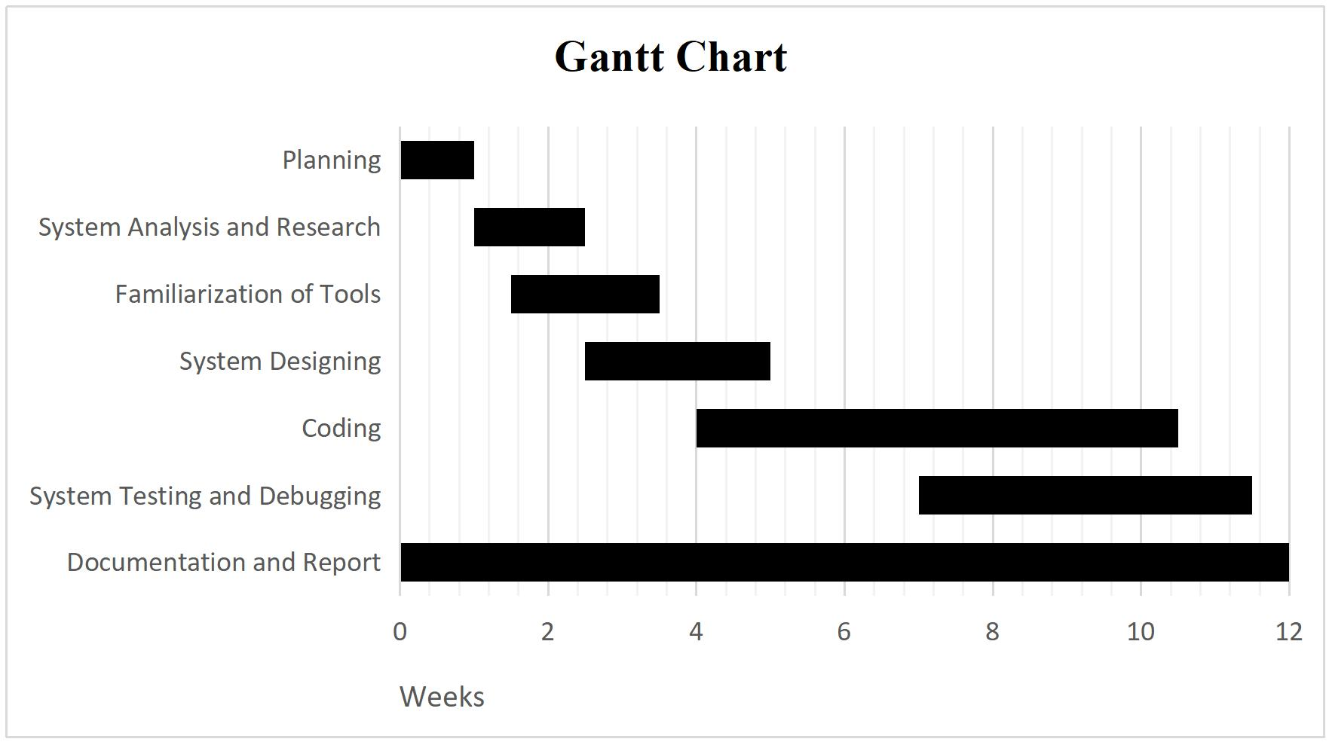

**Figure 2****: Gantt chart for Working Schedule**

## 3.3 System Requirements

### 3.3.1 Hardware Requirements

* A standard computer (<i3 5th Gen, 4 GB ram or Higher)
* Hard Disk to store all the images

3.3.2 Software Requirements

* Python django Framework
* VS code Text editor
* Python 2.7+
* Windows OS or Linux OS
* Latest version of Python Libraries

## 3.4 Analysis

In order to develop system that addresses the need of each and every organizations, institutions we carried out various methods to collect the required data. We went through various articles and web resources. Going through the various sites related to project field, we will analyze the feedback from the colleges and administrations of various organizations. We are planning to conduct more surveys ahead to collect the required information about the client’s opinion who are going to use our system. Furthermore, we are planning to conduct questionnaire with multiple choice question for the student, players and administrators. Hence, we are planning to collect our remaining requirement by using different methodology like questionnaire, surveys, one to one talk, group discussion, etc.

### 3.4.1 Class and object diagram

In our project, a class diagram can be used to visualize the classes in the system, their attributes and methods, and their relationships with other classes. It can help to identify the major components of the system and how they interact with each other.

Similarly, an object diagram can be used to visualize the specific instances of classes in the system and their relationships at a particular moment in time. It can help to identify the state of the system at a given point and how the objects are interacting with each other.

Together, these two diagrams can provide a comprehensive understanding of the system's structure and behavior, and help us to design, implement and maintain the system effectively.

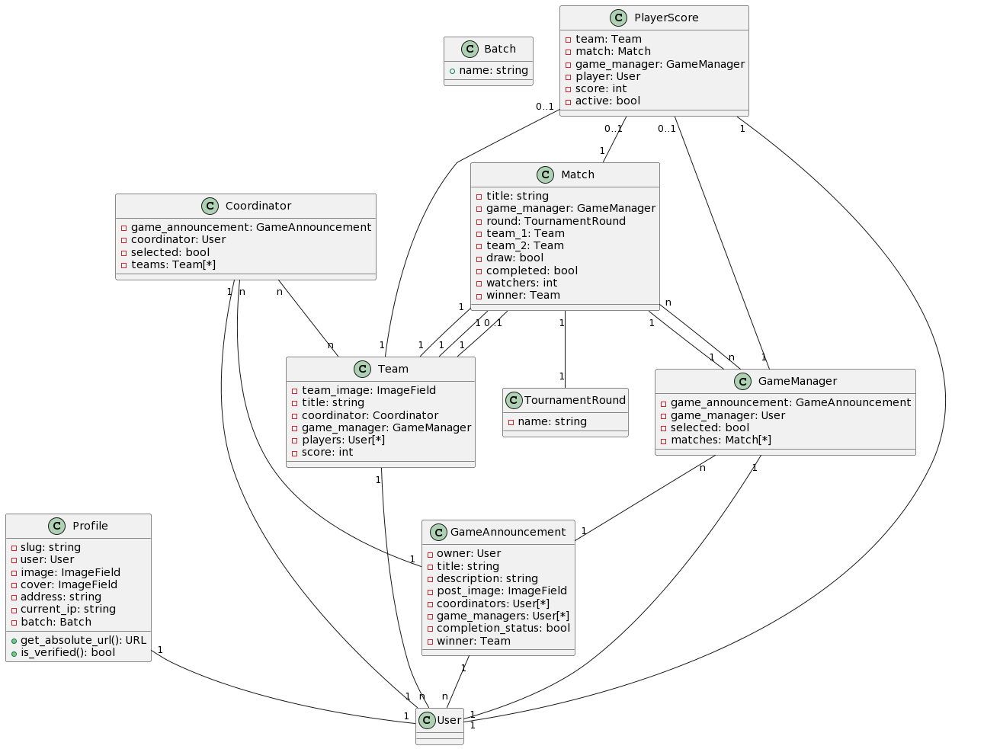

**Figure 3****: Class and Object Diagram**

### 3.4.2 Sequence Diagram

In our project, the user can gain a better understanding of the interactions between different objects in the system and how they work together with the help of sequence diagram. In the MacFutsal, there are four main components: admin, user, game manager, and class coordinator. The class coordinator is responsible for creating teams, while the game manager is responsible for managing the game

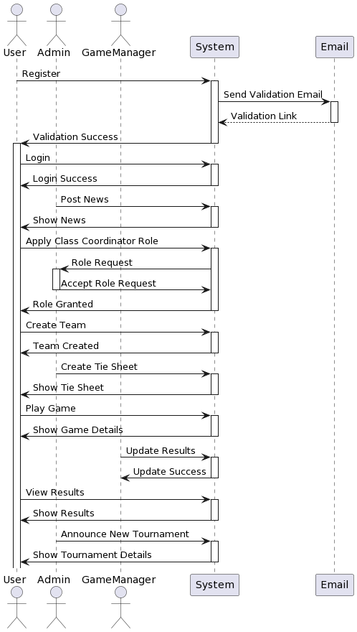

**Figure 4****: Sequence Diagram**

### 3.4.3 Activity Diagram

In the context of a MacFutsal, activity diagrams can be used to model and communicate the various processes and workflows that are involved in managing a futsal facility or team.

Here are some examples of how activity diagrams can be used in a MacFutsal :

* **Booking system**: The user can book the futsal court by selecting the date and time, checking availability, and receiving confirmation.
* **Player registration**:The class coordinator is responsible for registering a new player, starting from the player submitting their personal information, verifying their eligibility, assigning them to a team, and updating the database.
* **Game management**: With the help of this ,Game manager manage the futsal game, starting from setting up the court, checking in the players, starting the game, keeping score, and ending the game.

By using activity diagrams in the design and management of a futsal system, we can improve communication, identify potential issues and bottlenecks, and ensure that all stakeholders are on the same page.

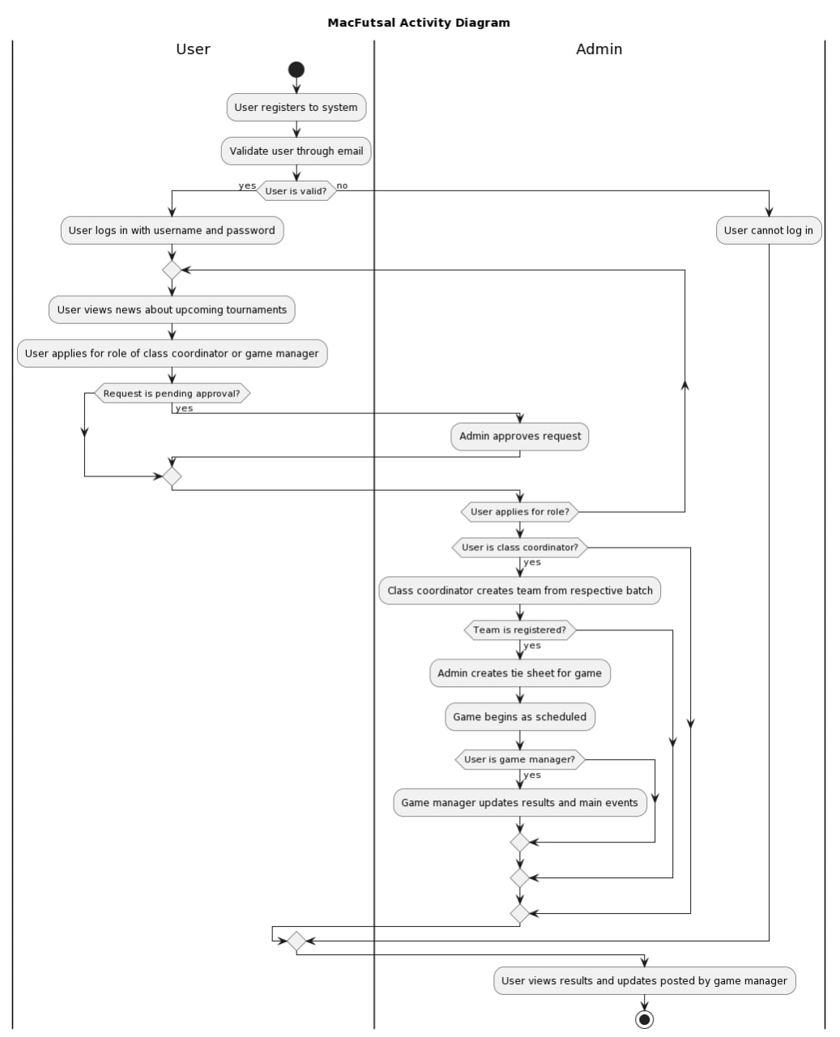

**Figure 5****: Activity Diagram**

## 3.5 Use Case Diagram

In MacFutsal, the use case diagram can help to illustrate the different functionalities that the system can perform to manage futsal courts, bookings, and other related activities.

In this use case diagram, there are four main actors: user, admin, class coordinator and game manager. Each actor can perform different actions or use cases within the system. For example, the Admin can manage the system by adding and removing courts, managing bookings, and generating reports. The Manager can manage the bookings, and schedule of the court(s) he/she is responsible for. The class coordinator is responsible for making a team of his/her batch and can book a court, and view his/her booking history. User or player should register his/her name and login to the website.

### 3.5.1 Use Case Diagram for User, Admin

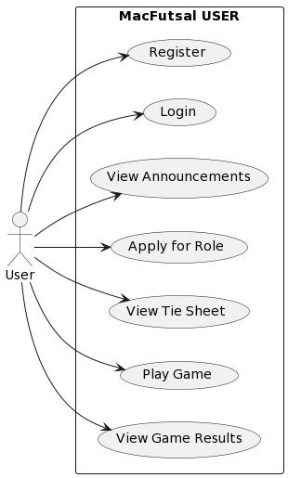

**Figure 6****: Use case diagram for user**

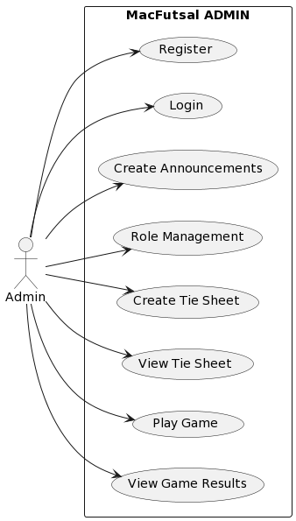

**Figure 7** **: Use case diagram for Admin**

### 3.5.2 Use Case Diagram for Class coordinator and Game manager

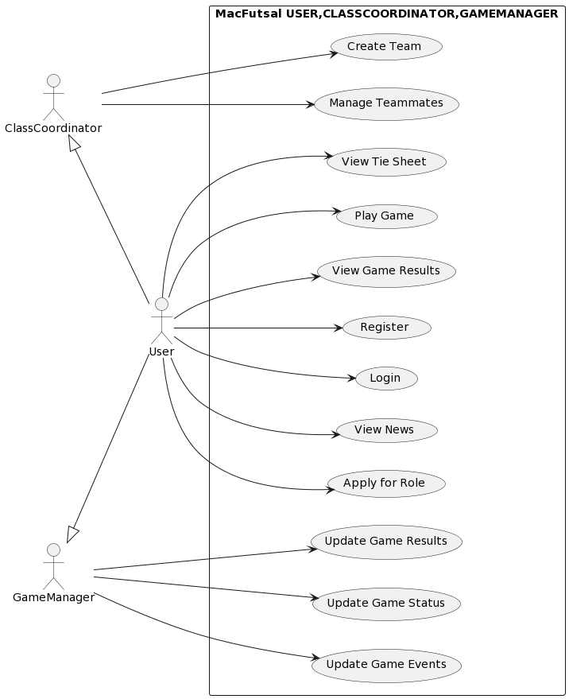

**Figure 8****: Use case diagram for Class coordinator and Game Manager**

**Chapter 4**

# SYSTEM DESIGN

## 4.1 Database Design

Our website has seven databases: admin, users, futsal announcement, futsal game, player score, team and team members. The admin database included information for the admin login. The user database contains all of the necessary information for user registration. The Futsal announcement includes the information about the game announcement. Futsal game database provide the information about Tournament, date when it started and end .The player score include the information about score, player id, game id .The team and team member database include all the necessary information about team, team member, user id, team id and score.

### 4.1.1 Database Table for Admin

**Table 1****: Database Table for Admin**

|  |  |  |  |  |
| --- | --- | --- | --- | --- |
| S.N. | Field | Data type | Length | Description |
| 1 | Id(Auto increment) | integer | 10 | Id of the admin registration |
| 2 | name | varchar | 50 | Username of the admin |
| 3 | email | varchar | 50 | Email of the admin |
| 4 | password | varchar | 50 | Password For the security |

### 

### 4.1.2 Database Table for User

**Table 2****: Database table for user**

|  |  |  |  |  |
| --- | --- | --- | --- | --- |
| S.N. | Field | Data type | Length | Description |
| 1 | Id(Auto increment) | Integer | 10 | User id assigned during registration |
| 2 | User Name | Varchar(Not NULL UNIQUE) | 150 | Username of user |
| 3 | email | Varchar(Not NULL) | 254 | Email of user |
| 4 | First name | Varchar (NOT NULL) | 150 | First name of user |
| 5 | Last name | Varchar (NOT NULL) | 150 | Last name of user |
| 6 | password | Varchar(NOT NULL) | 128 | Password for security |
| 7 | Date joined | datetime (NOT NULL) |  | Date of user joined |
| 8 | Is_staff | Bool (NOT NULL) | 1 | Staff status |
| 9 | Is_ClassCoordinator | Bool (NOT NULL) | 1 | Is user given role of Class Coordinator |
| 10 | Is_Game Manager | Bool (NOT NULL) | 1 | Is user assigned role of Game Manager. |

### 4.1.3 Database Table for Game Announcement

**Table 3****: Database table for Game Announcement**

|  |  |  |
| --- | --- | --- |
| S.N. | Field | Length |
| 1 | Id | 10 |
| 2 | Title | 240 |
| 3 | Created at |  |
| 4 | Updated at |  |
| 5 | Coordinator_id | 10 |

### 4.1.4 Database Table for Futsal Game

**Table 4****: Database table for Futsal Game**

|  |  |  |  |
| --- | --- | --- | --- |
| S.N. | Field | Data type | Length |
| 1 | Id | Integer (NOT NULL) | 10 |
| 2 | Title | varchar(NOT NULL) | 240 |
| 3 | Created at | Datetime(NOT NULL) |  |
| 4 | Updated at | Datetime(NOT NULL) |  |
| 5 | GameManger_id | integer(NOT NULL) | 10 |

### 4.1.5 Database Table for Player Score

**Table 5****: Database table for Player score**

|  |  |  |  |
| --- | --- | --- | --- |
| S.N. | Field | Data type | Length |
| 1 | Id | Integer (NOT NULL) | 10 |
| 2 | Score | varchar(NOT NULL) | 240 |
| 3 | Game id | Datetime(NOT NULL) |  |
| 4 | Player id | Datetime(NOT NULL) |  |
| 5 | Team id | Bigint(NOT NULL) | 10 |

### 4.1.6 Database Table for Teams

**Table 6****: Database table for Teams**

|  |  |  |  |
| --- | --- | --- | --- |
| S.N. | Field | Data type | Length |
| 1 | Id | Integer (NOT NULL) | 10 |
| 2 | Team name | varchar(NOT NULL) | 240 |
| 3 | Score | Real(NOT NULL) | 10 |
| 4 | Created at | Datetime(NOT NULL) |  |
| 5 | Updated at | Datetime(NOT NULL) |  |
| 6 | coordinator_id | integer(NOT NULL) | 10 |

### 4.1.7 Database Table for Team Members

**Table 7****: Database table for Team Members**

|  |  |  |  |
| --- | --- | --- | --- |
| S.N. | Field | Data type | Length |
| 1 | Id | Integer(NOT NULL) | 10 |
| 2 | Team id | Bigint(NOT NULL) | 10 |
| 3 | User id | integer(NOT NULL) | 10 |

## 4.2 Component Diagram

In our project, the component diagram shows the various components of the futsal management system and how they interact with each other to provide a seamless user experience.

In this diagram, we can see the various components of the futsal management system, as well as their dependencies and interfaces. Here's a breakdown of each component:

* **User Interface Component**: In MacFutsal, this component represents the user interface of the system, which allows users to interact with the system and perform various tasks such as booking a futsal court or registering as a player.
* **Booking Component:** This component handles the booking of futsal courts, including checking availability, reserving the court, and updating the booking database.
* **Registration Component:** This component handles player registration, including collecting player information, assigning players to teams, and updating the player database.
* **Game Management Component:** This component manages futsal games, including setting up the court, checking in players, keeping score, and ending the game.

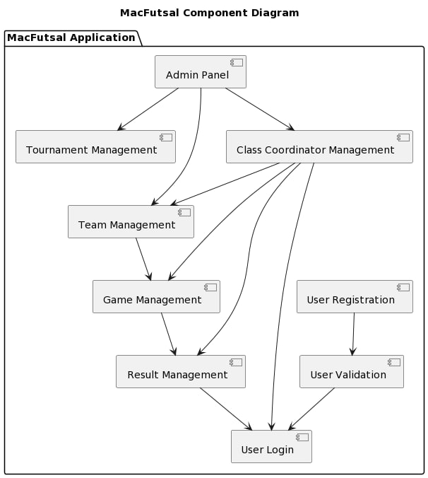

**Figure 9****: Component Diagram**

## 4.3 Deployment Diagram

In MacFutsal, the deployment diagram shows the physical deployment of the futsal management system onto hardware and infrastructure. This diagram can be used to plan and manage the deployment of the system, as well as to identify potential issues and bottlenecks in the deployment process.

Here's a breakdown of each component:

* **Web Server**: In our project, the web server(futsal App) hosts the user interface component of the system, which users can access through a web browser.
* **Application Server**: The application server hosts the booking, registration, game management, payment, and notification components of the system. These components handle the business logic of the system and interact with the database.
* **Database Server:** The database server hosts the database component of the system, which stores all the information for the system, including bookings, players, payments, and other data.

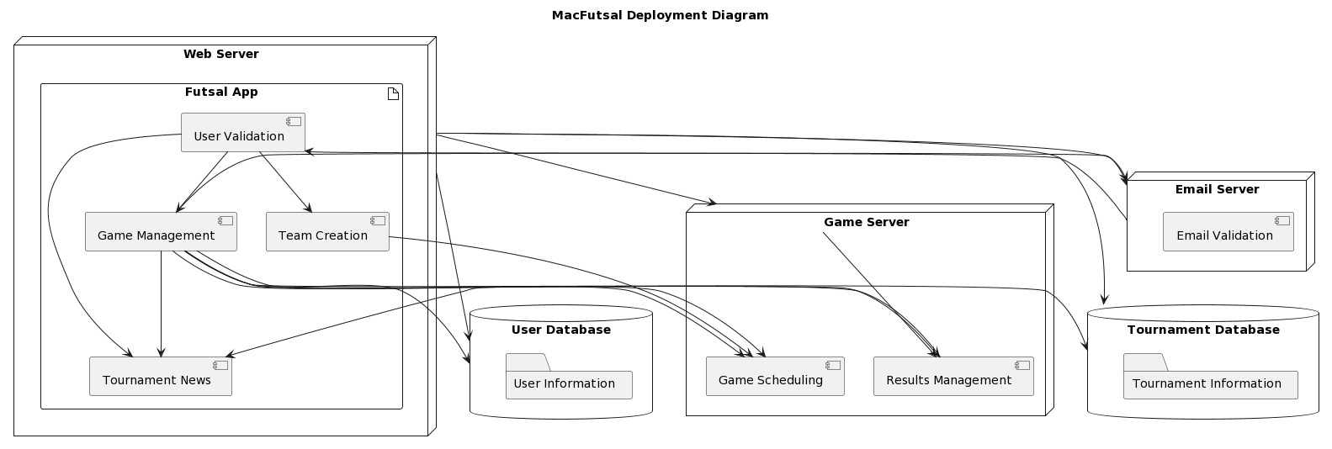

**Figure 10****: Deployment Diagram**

## 4.4 Overall Flow Diagram

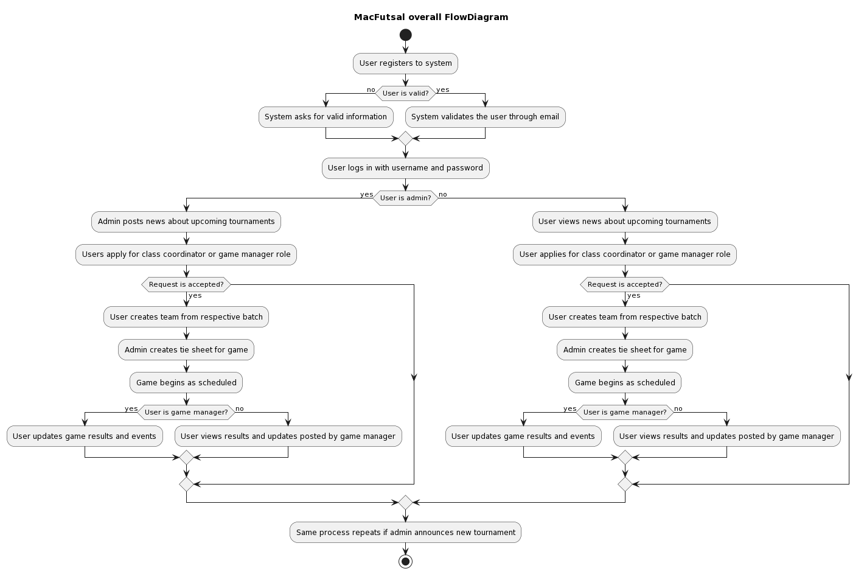

**Figure 11: Overall Flow Diagram**

**Chapter 5**

# IMPLEMENTATION AND TESTING

## 5.1 Implementation

Implementing a futsal management system can be done in various ways, but here is a general guideline to get started:

* Define the Requirements: Begin by identifying the requirements of the futsal management system. This could include player registration, scheduling of games, payment processing, and so on.
* Choose the right platform: There are various platforms available that can be used for building a futsal management system. You could choose to build the system from scratch using programming languages such as Python or Ruby, or you could use existing frameworks like Word Press or Django.
* Design the database: Once you have identified the requirements and the platform, you will need to design the database to store the data. A database is essential for storing player profiles, game schedules, and other important information.
* Build the user interface: A user interface is essential for players, coaches, and administrators to interact with the system. You could choose to build a web-based interface or a mobile app.

### 5.1.1. Tools/Libraries Used

* **Front End**

**a.HTML**

It is the standard markup language for documents to be displayed in a web browser. We used HTML to display the content and structure of the web pages in our project.

**b.CSS**

CSS stands for Cascading Style Sheets. This is a very powerful language for formatting the web pages and has been of great help in our project. I used it to format the user interface in order to make it more appealing to the users.

**c. JavaScript**

It is the scripting language of HTML and the web. We used JavaScript for enabling interactive Web Pages in our project.

**d. Bootstrap**

It is the Framework for CSS. In our Project we will be using bootstrap. We used bootstrap framework for creating layouts as it is compatible with all modern browsers.

* **Back End**

**a. Python**

Python is a popular server side programming language. It is used for Web development, software development, mathematics, system scripting. Python can be used on a server to create web applications, connect to database system. It can also read and modify files. Python has a simple syntax similar to the English language.

* **Software Tools Used**

**a. Django**

Django is an open-source framework for back-end web application based on Python --One of the top web development languages. Its main goals are simplicity, flexibility, reliability, and scalability. Django has its own naming system for all functions and components. Django helps us write software that is Complete, Versatile, Secure, Scalable, Maintainable, and Portable.

**b. SQLite**

SQLite is a software library that implements a self-contained, server less, zero-configuration, transactional SQL database engine. SQLite is the most widely developed SQL database engine in the world. SQLite is an open-source software project, and the source code is available under the terms of the SQLite license. The source code for SQLite is in the public domain. It is easy to use, lightweight, server-less, cross-platform, and, highly reliable.

## 5.2 Testing Approaches

Software testing is a set of process aimed at investigating, evaluating and ascertaining the completeness and quality of computer software. Software testing ensures the compliance of a software product in relation with regulatory, business, technical, functional and user requirements. The objectives of these processes can include:

* Verifying software completeness in regards to functional/business requirements.
* Identifying technical bugs/errors and ensuring the software is error-free.
* Assessing usability, performance, security, compatibility and installation.

### 5.2.1 Unit Testing

During the coding phase each individual module was tested to check whether it works properly or not. Different errors found during unit testing were debugged. Some of the test cases are listed below:

**Test Case: User Login**

**Table 8****: User Login**

|  |  |  |  |  |
| --- | --- | --- | --- | --- |
| **S.N** | **Test Inputs** | **Expected Output** | **Actual Output** | **Result** |
| **1.** | When user provide correct username and password:  **Username:** mabisha@gmail.com  **password:** qwerty | Login should be success. | Login successful | Test Successful |
| **2.** | When no username and password is provided:  **Username:**  **Password:** | Required fields are empty. | Required fields are empty. | Test Successful |

|  |  |  |  |  |
| --- | --- | --- | --- | --- |
| **3.** | When username is provided with incorrect password:  **Username**: ram@gmail.com  **Password:** @qwerty123 | Invalid password | Invalid Password | Test Successful |

**Test Case: User Registration**

**Table 9****: User Registration**

|  |  |  |  |  |
| --- | --- | --- | --- | --- |
| **S.N** | **Test Inputs** | **Expected Output** | **Actual Output** | **Result** |
| **1.** | **First Name:** Mabisha  **Last Name:** Koirala  **Address:** Pokhara  **Email:**mabisha11@gmail.com  **Password:** @#abc123 | Successfully Registered | Successfully Registered | Test successful |
| **2.** | **First Name:** Ramesh  **Last Name:** B.k  **Address:** Ghandruk  **Email:**  **Password:** #mnbvcxz5432 | Registration should be failed | Fill out the required field. | Test Successful |

### 5.2.2 Stress Testing

This is the testing method that always tests the behavior of a system when subjected to unusual conditions. I tested the system with invalid input data such as unfilled input fields and no execution could continue.

### 5.2.3 Actual system Testing

This is done to the entire system to test the general working of the system after it has been fully developed .This test will be done on this system to test whether the objective stated earlier have been achieved or not.

### 5.2.4 Functional Testing

This involves testing the functions of the program by provide an input data and observing the output. This will be done to test the working of the various functions of the program and any unexpected behavior will be identified and corrected accordingly.

### 5.2.5 System Testing

System testing was done after integrating testing in order to ensure that the whole system function properly. After the integration testing the whole system working process was checked.

* **White Box Testing**

The internal working or code of a system application was working properly.

* **Black Box Testing**

The output was as per the system specification and hence the system was found to work properly.

**Table 10****: Result of Few Testing**

|  |  |  |  |
| --- | --- | --- | --- |
| **S.N** | **Expected Result** | **Actual Result** | **Pass/Fail** |
| **1** | Login | As Expected | Pass |
| **2** | Display Teammates | As Expected | Pass |
| **3** | Show result | As Expected | Pass |
| **4** | Display Fixtures | As Expected | Pass |
| **5** | Player information | As Expected | Pass |

### 5.2.6 Acceptance Testing

During the testing process, any invalid data input altered the expected results and the system validation functions could alert the user of these invalid inputs. The system validation was also subjected to potential users for feedback and acceptance tests and I got a positive response from these users whereby they accepted the system as a solution to inefficient manual operation in modern Futsal management system .Acceptance testing was done after the completion of development process where the system was delivered to the users for their views and once they accepted the system, then the system is said to have met the user requirement.

## 5.3 Outcomes

A MacFutsal system can have several potential outcomes, including:

* **Improved organization**: With the help of the MacFutsal, game managers and class coordinators can easily organize games and classes, respectively. They can also communicate with users about schedules, locations, and other important information.
* **Better user experience**: Users can easily register for games and classes, track their progress, and receive updates about upcoming events. They can also provide feedback to game managers and class coordinators, which can help improve the overall experience.
* **Increased efficiency**: The MacFutsal can automate many tasks, such as scheduling games and classes, sending E-mail. This can save time and reduce errors.
* **Enhanced security**: The system can have role-based access control, which means that only authorized users can access certain functions. This can help prevent unauthorized access to sensitive information and reduce the risk of data breaches.

Overall, a well-designed MacFutsal with clear roles and responsibilities can lead to a more efficient, organized, and enjoyable futsal experience for all involved.

**Chapter 6**

# MAINTENANCE AND SUPPORT

The information relevant to the functionality of the system is stored in the database, which is designed to maintain consistent state even when an application error occurs the most effective way to recover from an error is to restart the application, either by closing and restarting the application or by refreshing the browser. In either case, a restart should have no negative effects on the database and the applications should function normally.

If however, the same error continually occurs, this likely indicates that the database has somehow been corrupted. Although measures have been taken to protect the consistency of the database, there may still be a slight chance of this corruption occurring through either user or intentional tampering. If the database becomes corrupted, a clean reinstalling of the system performed.

Here's how your MacFutsal Application project can be approached from a corrective, adaptive, preventive, and perfective maintenance perspective:

## 6.1 Corrective maintenance

This type of maintenance involves fixing issues that are identified in the system. In your case, corrective maintenance would involve identifying and fixing any bugs or errors that users encounter while using the application. This could include issues with user registration, email verification, or team management functions. To perform corrective maintenance, you could:

* Monitor user feedback and complaints to identify areas of the application that require attention.
* Conduct regular testing and debugging to identify and fix any bugs that arise.
* Implement tools and technologies that can help automate the process of bug identification and resolution.

## 6.2 Adaptive maintenance

This type of maintenance involves modifying the system to meet changing user needs or requirements. In your case, adaptive maintenance might involve adding new features or functionality to the application to enhance user experience. To perform adaptive maintenance, you could:

* Gather user feedback to identify areas of the application that users would like to see improved or expanded.
* Conduct market research to identify emerging trends or features that could be added to the application.
* Work with developers to modify the application and add new features as required.

## 6.3 Preventive maintenance

This type of maintenance involves identifying and fixing potential issues before they become major problems. In your case, preventive maintenance might involve identifying security vulnerabilities or performance issues that could impact user experience. To perform preventive maintenance, you could:

* Conduct regular security audits to identify potential vulnerabilities in the application.
* Monitor server and network performance to identify potential bottlenecks or slowdowns.
* Implement backup and recovery systems to ensure that user data is protected in the event of a system failure.

## 6.4 Perfective maintenance

This type of maintenance involves enhancing the system to improve its overall quality or performance. In your case, perfective maintenance might involve optimizing the application's performance or improving its user interface. To perform perfective maintenance, you could:

* Conduct regular usability tests to identify areas of the application that could be improved.
* Monitor system performance to identify potential bottlenecks or areas of inefficiency.
* Work with developers to optimize code or improve system architecture to enhance performance.

**Chapter 7**

# CONCLUSION AND FUTURE RECOMMENDATIONS

## 7.1. Conclusion

MacFutsal Management System is a comprehensive solution for managing futsal tournaments in a college setting. The system streamlines the process of applying for roles like Class Coordinator and Game Manager, and allows users to register teams for tournaments. The system also provides a platform for updating news and results of completed games. With the system, college futsal tournaments can be managed efficiently and transparently, enhancing the overall experience for participants and spectators alike.

## 7.2 Limitations of the System

* **Limited accessibility**: The system may only be accessible to those who have an internet connection and access to the website. This may exclude certain users who do not have access to technology or who are not comfortable using online platforms.
* **Dependency on human input:** The system relies heavily on the input of users, particularly Class Coordinators and Game Managers, to update game results, news, and other information. Human error or delays in inputting this information could affect the accuracy of the system.
* **Limited scope:** The system is designed specifically for futsal tournaments at a particular college, which means it may not be suitable for managing other types of tournaments or events.
* **Security concerns:** While the system verifies user email addresses during registration, there is a risk of unauthorized access to user information or system data. Proper security measures need to be in place to prevent any such breaches.
* **Lack of integration:** The system may not be fully integrated with other systems or platforms, such as social media, which could limit its effectiveness in promoting the tournament or reaching a wider audience.

## 7.3 Future Enhancements

There are limitations in our web application. To overcome those limitations, we plan to add the following features to our applications:

* **Mobile App**: Develop a mobile application for the system so that users can easily access the system's features and functionalities from their Smartphone.
* **Integration with Social Media**: Integrate the system with social media platforms such as Facebook, Twitter, and Instagram to allow users to share their team's performance and achievements.
* **Online Payment:** Implement a payment gateway for online payment of registration fees, team jerseys, and other expenses associated with the tournament.
* **Real-time Analytics:** Introduce real-time analytics for the tournaments to provide useful insights such as player performance, team performance, and tournament statistics to coaches, players, and organizers.
* **AI-Powered Scheduling:** Use artificial intelligence algorithms to optimize tournament scheduling, reducing conflicts and ensuring a fair distribution of matches.

# REFRENCES

[1] A. F. Md Ali, M. S. Amin, and M. F. Ismail, "Development of futsal tournament management system for higher education institution," Indonesian Journal of Electrical Engineering and Computer Science, vol. 23, no. 1, pp. 281-288, Jan. 2021.

[2] Q. A. Al-Radaideh, M. A. Alwesha, and H. A. Al-Masaeed, "Developing a web-based futsal management system for universities," International Journal of Computer Science and Network Security, vol. 18, no. 3, pp. 107-113, Mar. 2018.

[3] M. S. Ahmad, M. S. Mohd, A. A. Rahman, and S. A. Shafei, "Development of futsal tournament management system for higher education institutions," International Journal of Advanced Computer Science and Applications, vol. 10, no. 9, pp. 28-34, Sep. 2019.

[4] G. Akyol, N. Ayar, and M. F. Yılmaz, "Futsal management system for a university," International Journal of Social Sciences and Education Research, vol. 6, no. 2, pp. 287-294, Jun. 2020.

[5] B.S. Raju, S. Sankaralingam, and A. R. Mohamed, "Futsal tournament management system using web-based technologies," International Journal of Innovative Technology and Exploring Engineering, vol. 10, no. 5S, pp. 337-341, Apr. 2021.

[6] Wikipedia contributors, "Agile Software Development," Wikipedia, The Free Encyclopedia,11June2014.[Online].Available: <https://en.wikipedia.org/wiki/Agile_software_development>. [Accessed: 10-Nov-2014].

[7] B. Akyol, G. Isiklar and T. Ilicak, "Development of a futsal management system for a Turkish university," Journal of Physical Education and Sport, vol. 20, no. 4, pp. 1904-1913, 2020.

[8] R. K. Raju, S. K. Behera, and B. Sethi, "Development of a futsal management system for a college in India," International Journal of Advanced Science and Technology, vol. 30, no. 4, pp. 1289-1297, Apr. 2021.

[9] R. Sharma and S. Singh, "Design and Development of Futsal Management System," 2018 2nd International Conference on Computing Methodologies and Communication (ICCMC), Erode, India, 2018, pp. 673-677, doi: 10.1109/ICCMC.2018.8473225.

[10] N. N. Islam, N. B. Hamid, S. A. Mamun, and S. A. Rahman, "Design and Implementation of an Online Futsal Management System," 2018 International Conference on Computer, Communication, Chemical, Materials and Electronic Engineering (IC4ME2), Khulna, Bangladesh, 2018, pp. 1-4, doi: 10.1109/IC4ME2.2018.8539785.

[11] N. B. Hamid, N. N. Islam, S. A. Mamun, and S. A. Rahman, "Development of an Online Futsal Management System," 2018 International Conference on Electrical, Computer and Communication Engineering (ECCE), Cox's Bazar, Bangladesh, 2018, pp. 1-5, doi: 10.1109/ECACE.2018.8531785.

[12] M. H. Tareque, M. J. Islam, and M. M. Hasan, "Futsal Management System: A Web-Based Application for Futsal Management," 2018 International Conference on Electrical, Computer and Communication Engineering (ECCE), Cox's Bazar, Bangladesh, 2018, pp. 1-4, doi: 10.1109/ECACE.2018.8531784.

[13] M. N. Hossain, M. K. R. Khan, M. M. Hossain, and S. M. M. Rahman, "Design and Implementation of an Online Futsal Management System," 2020 International Conference on Computer, Communication, Chemical, Materials and Electronic Engineering (IC4ME2), Dhaka, Bangladesh, 2020, pp. 1-4, doi: 10.1109/IC4ME2.2020.9061351.

# 

# APPENDIX

# **9.1 Screenshots**

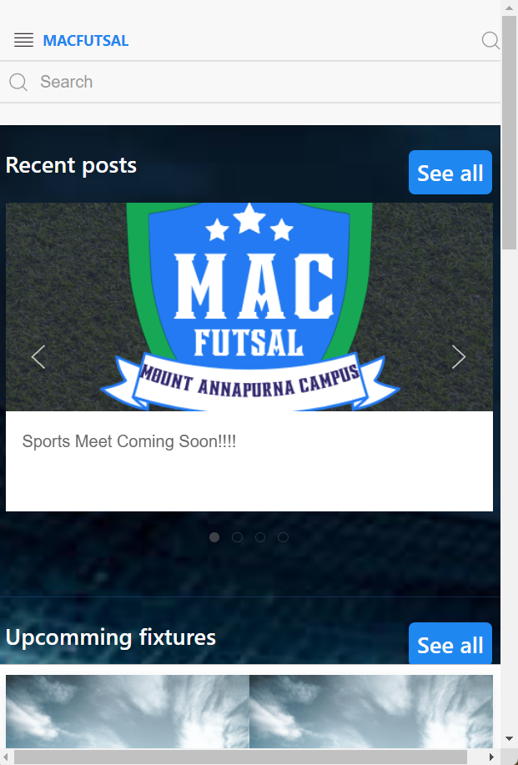

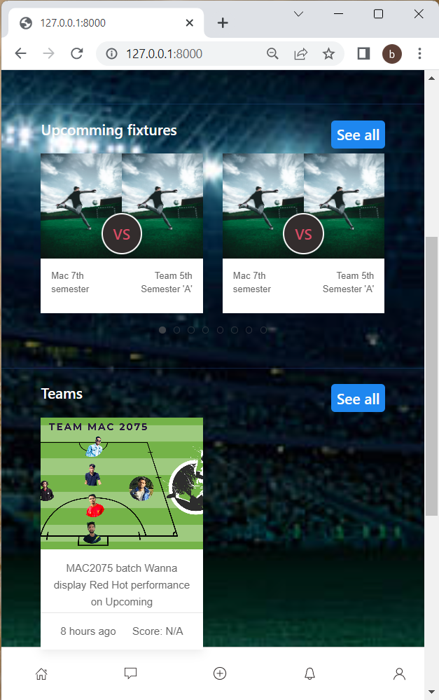

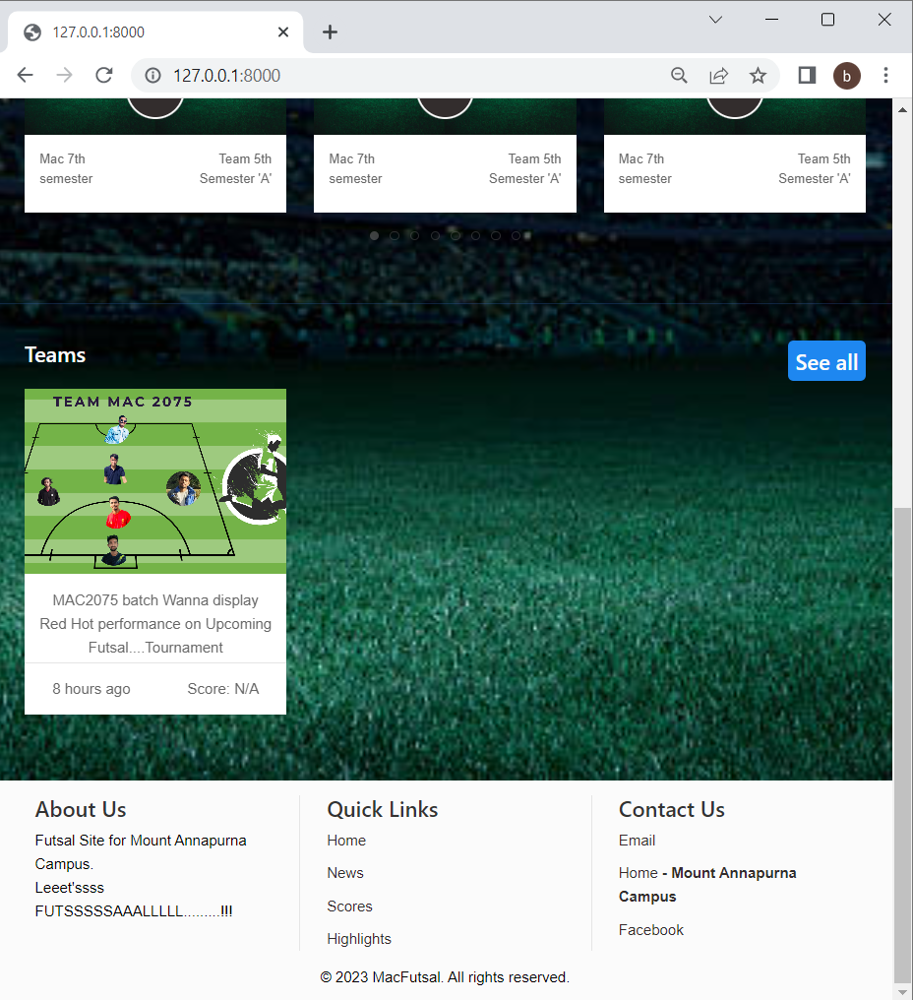

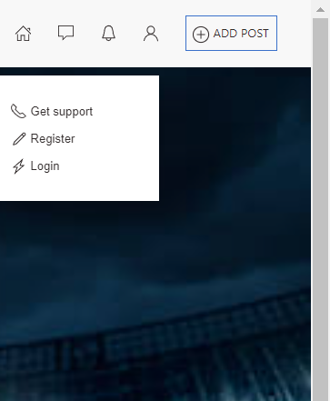

Login Panel

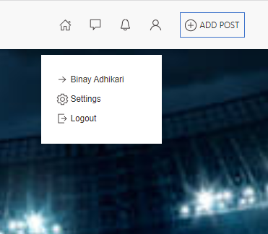

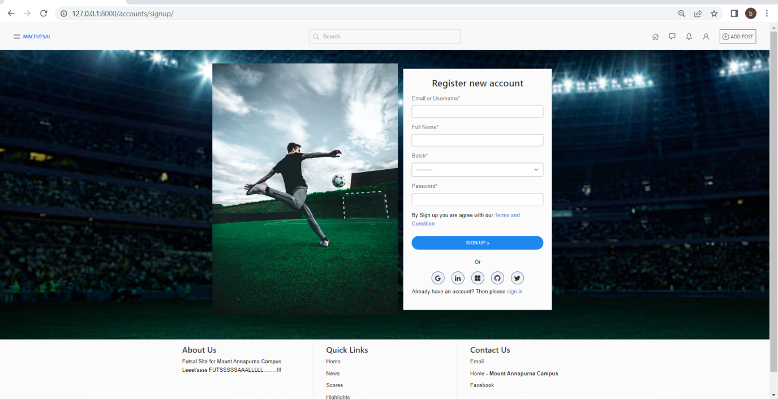

Register Panel

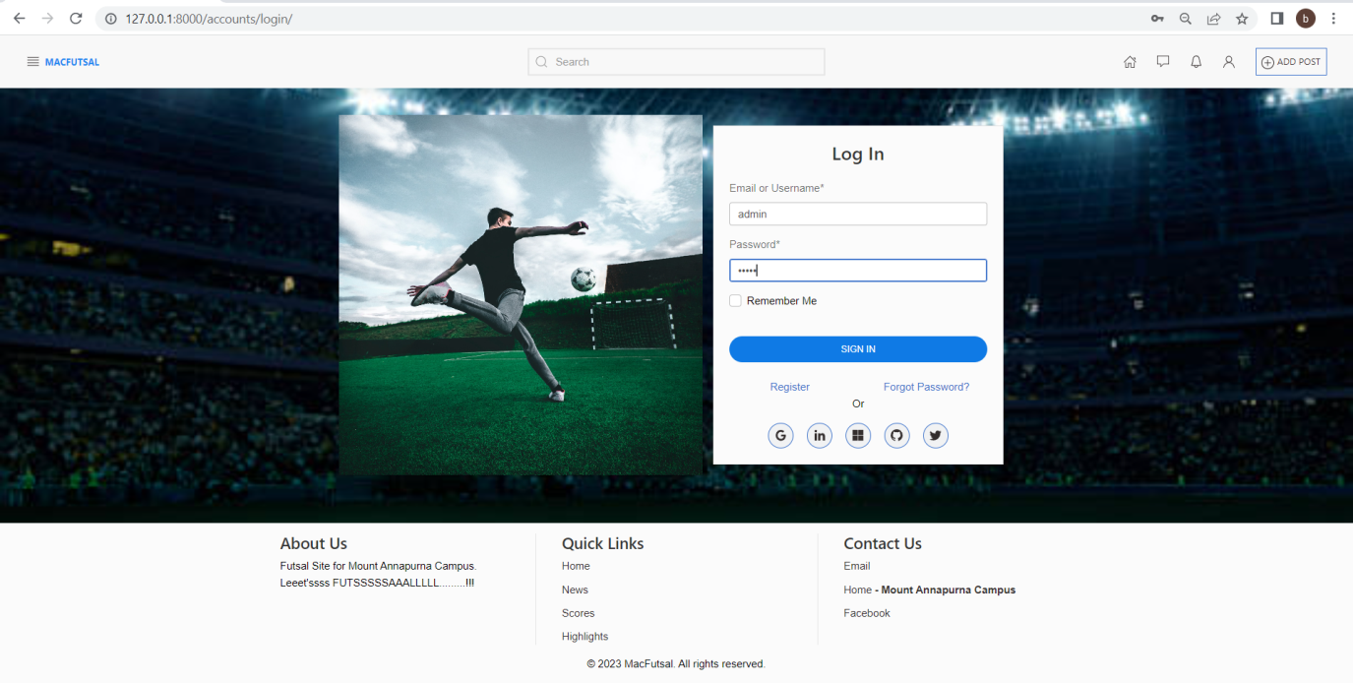

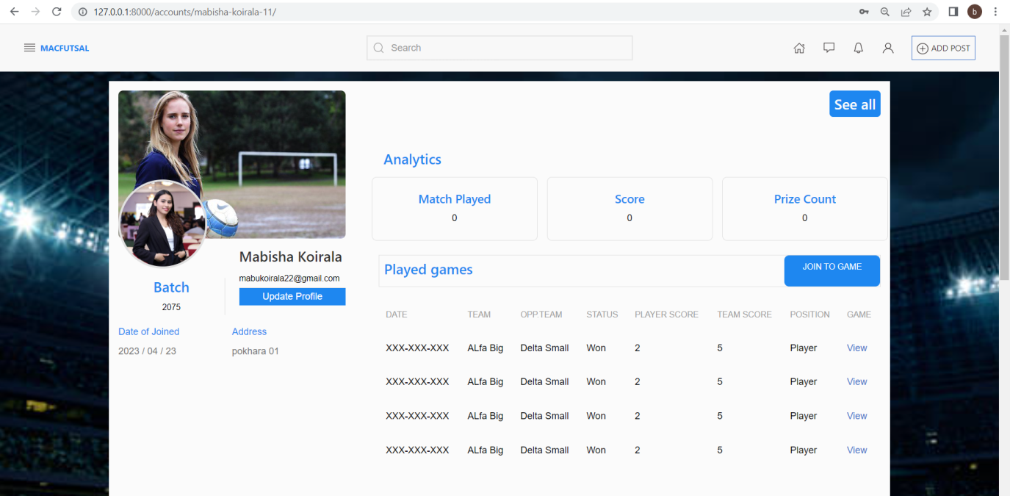

Profile Picture updates

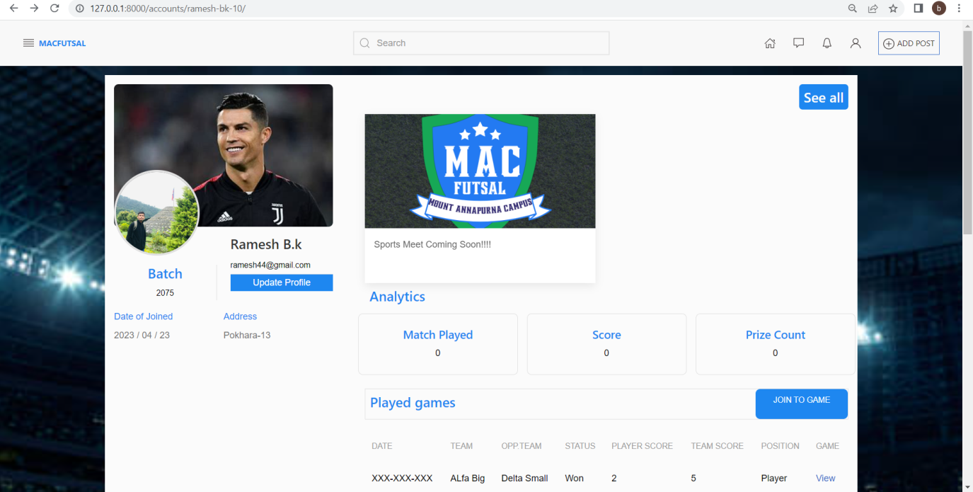

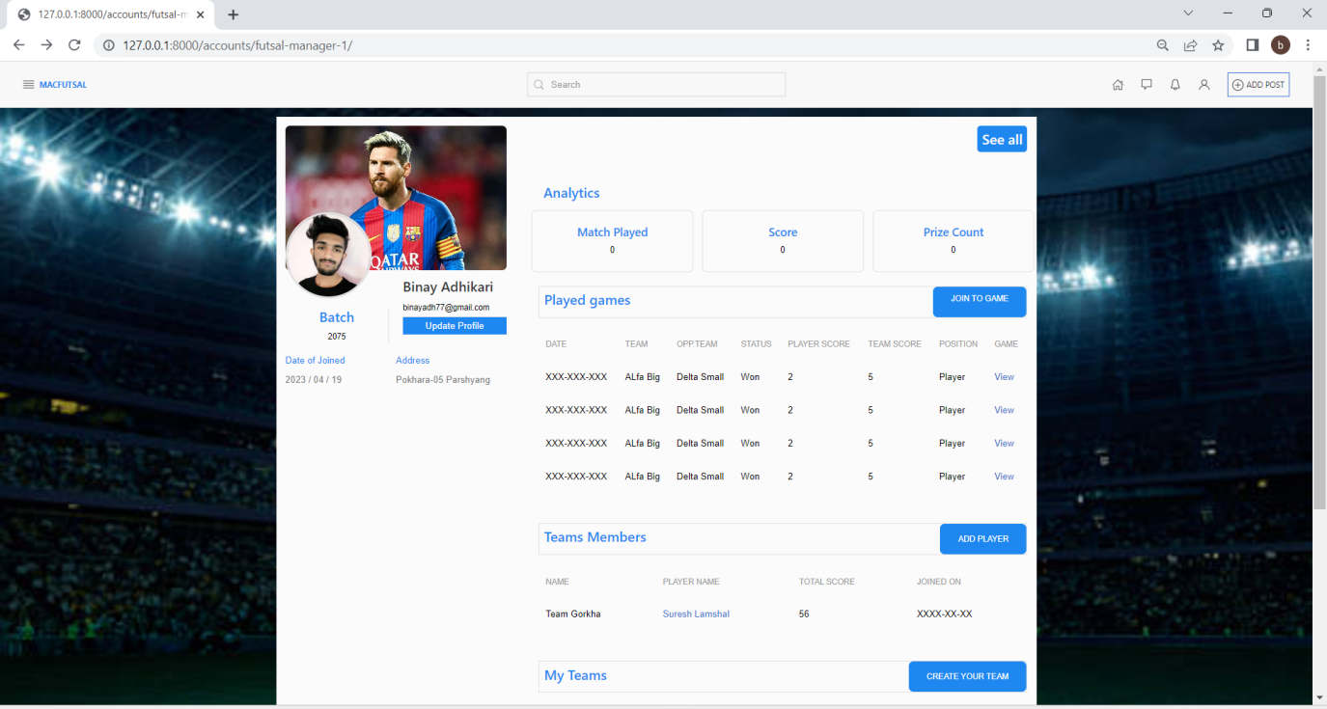

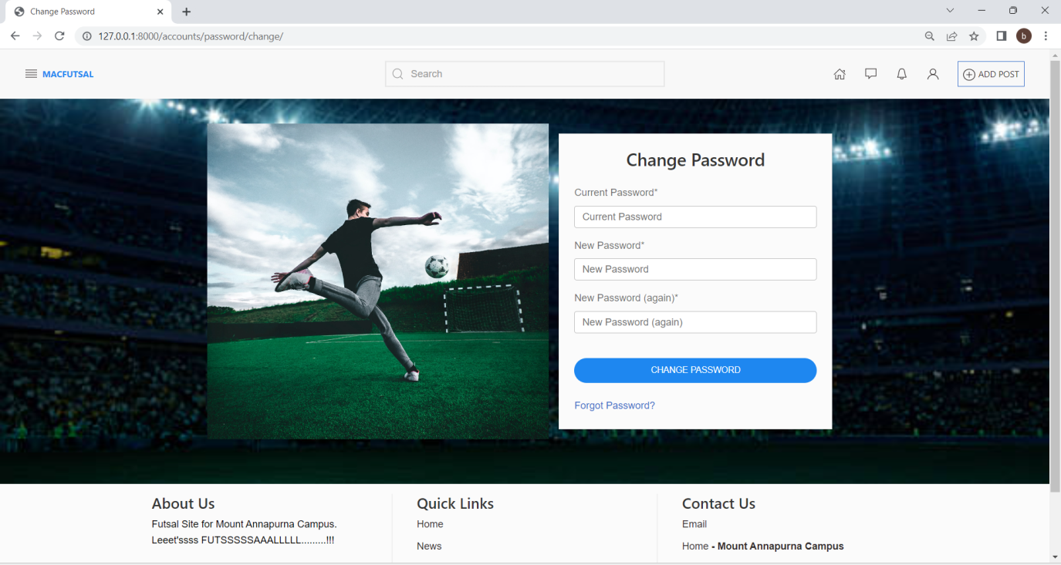

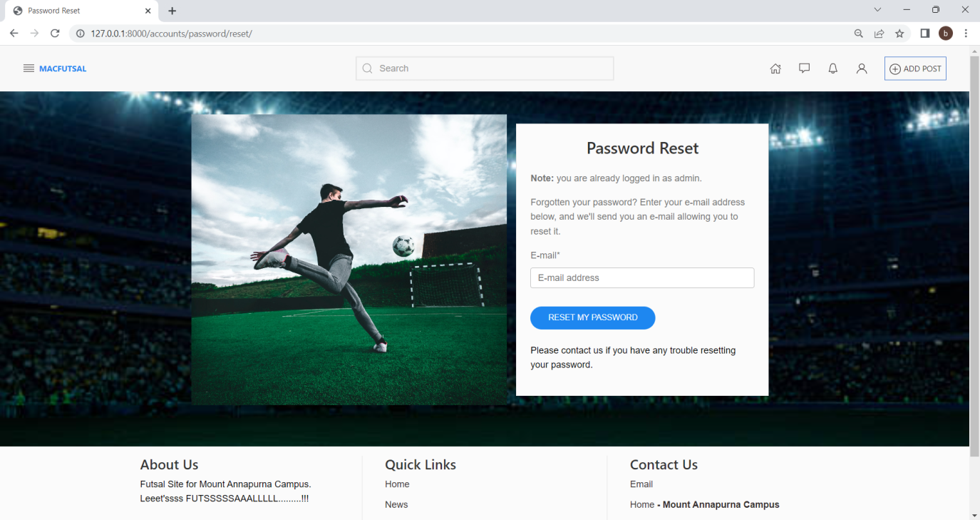

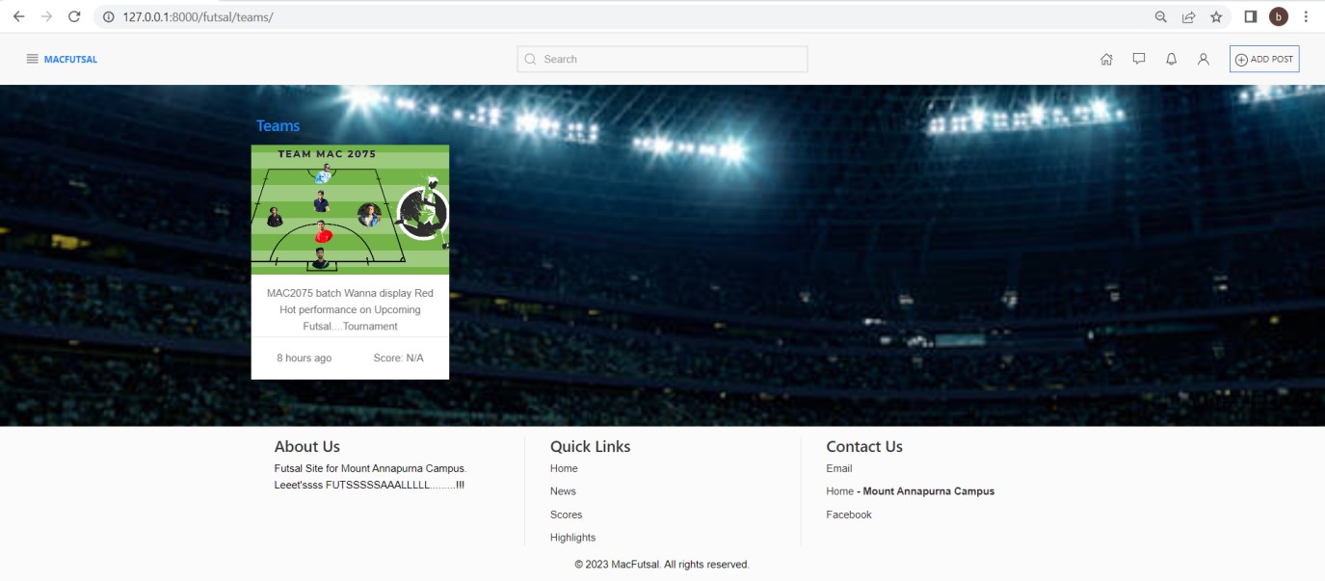

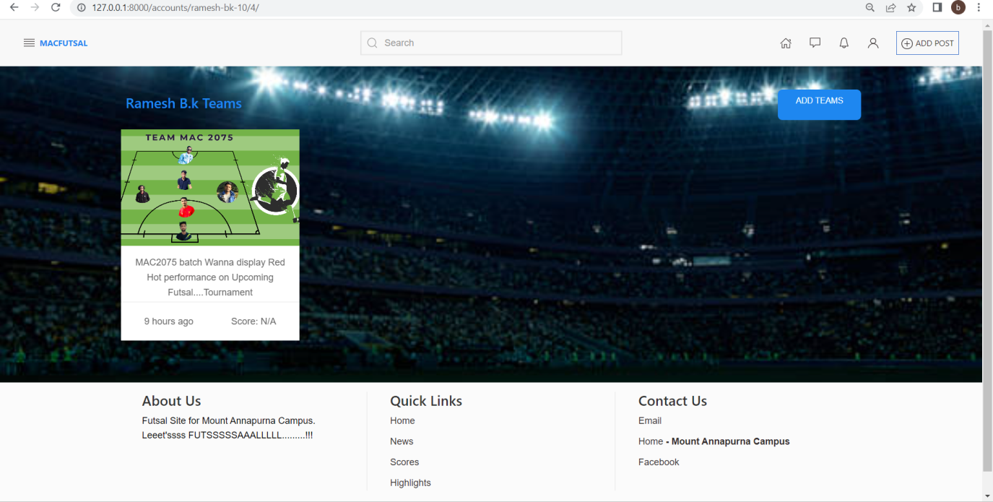

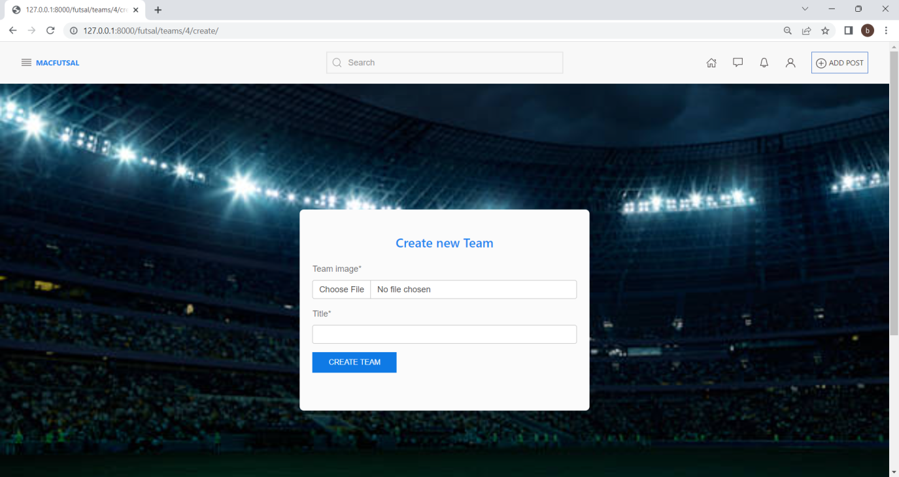

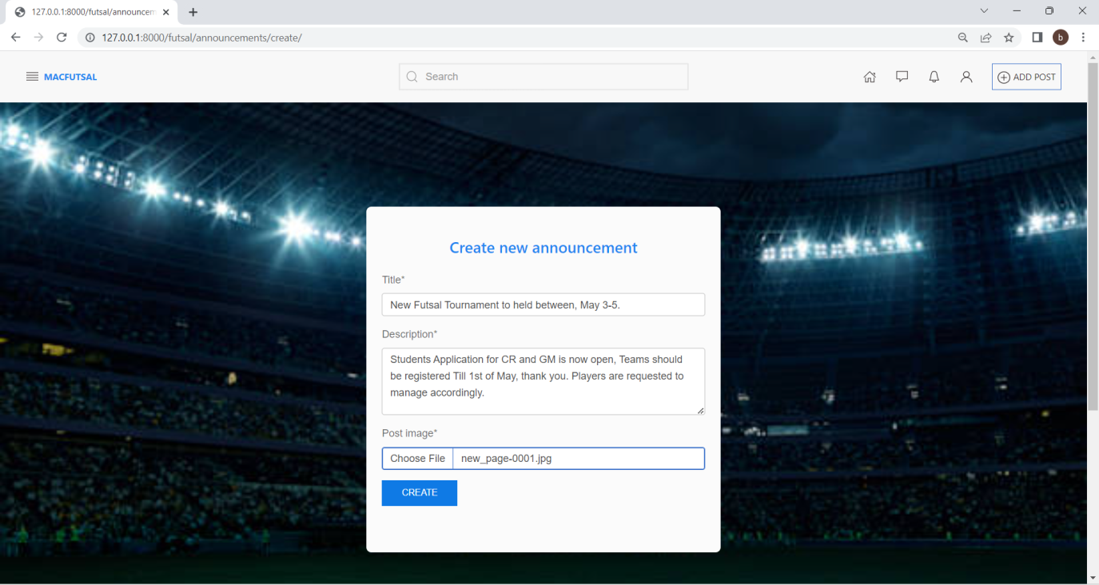

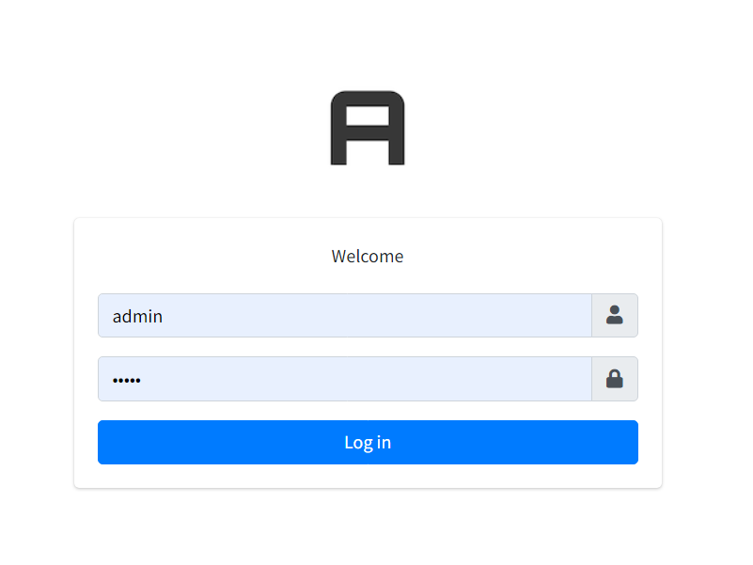

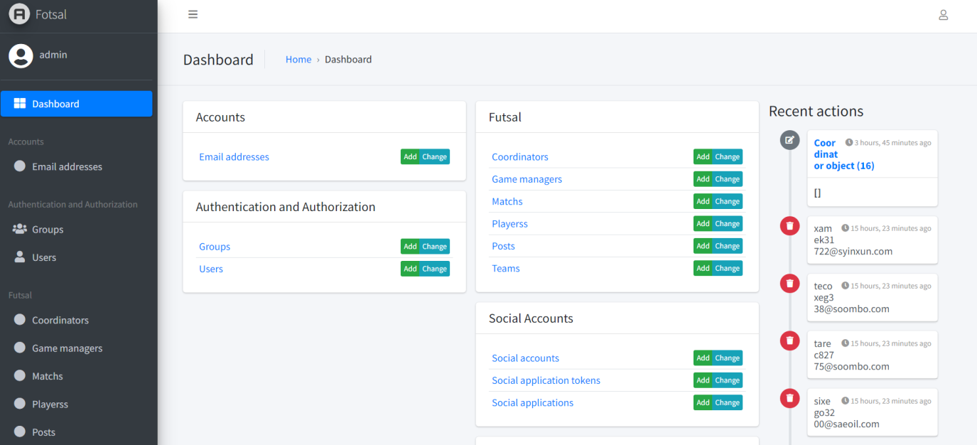

Admin Panel and Dashboard for User Roles and Permissions management .

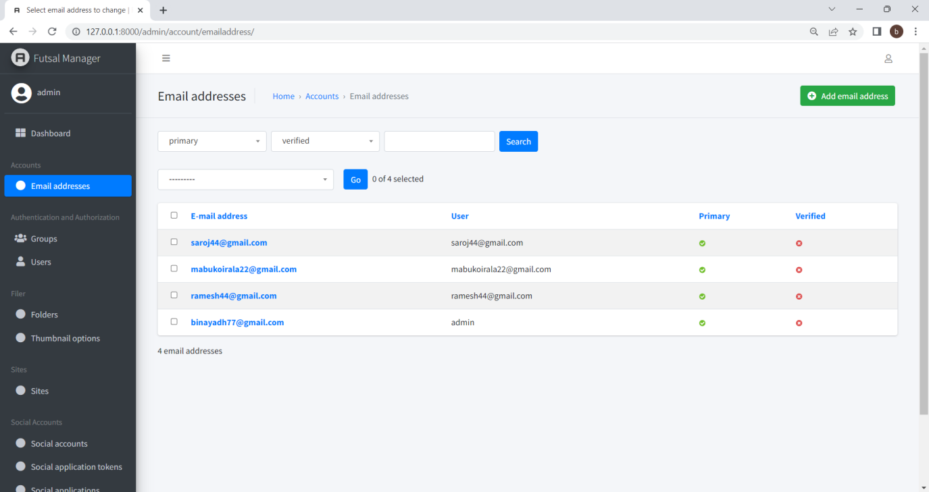

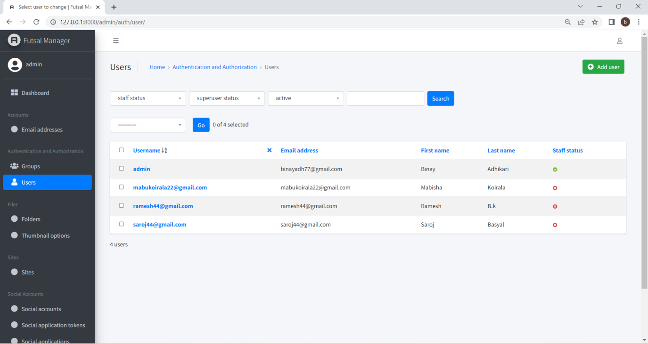

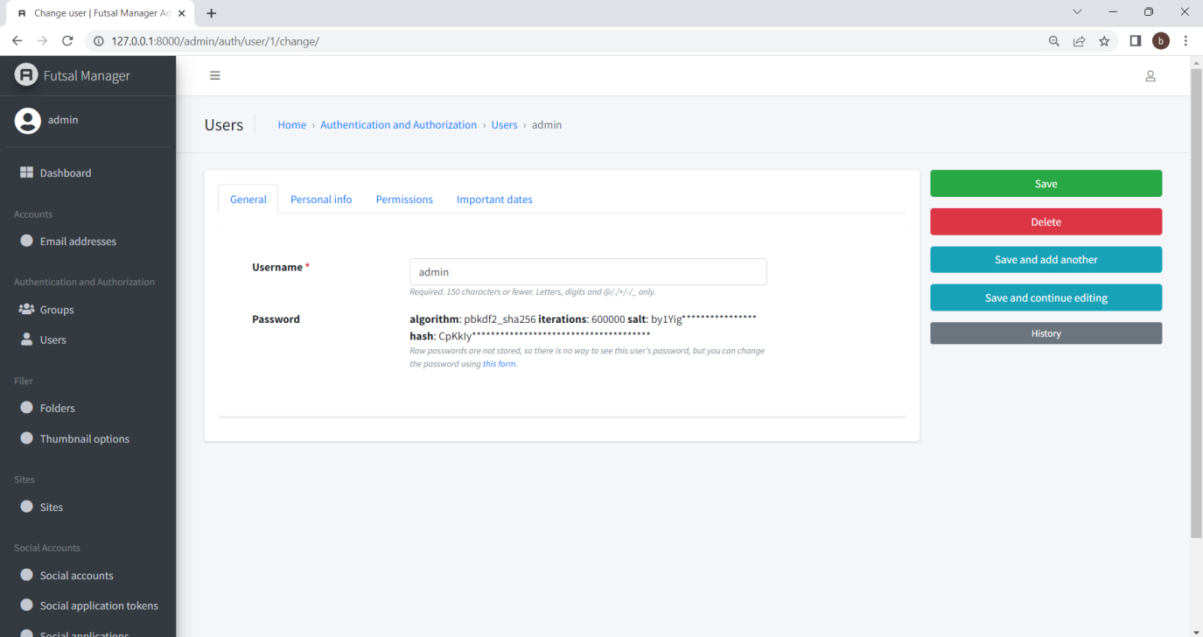

Django uses the PBKDF2 algorithm (Password-Based Key Derivation Function 2) with a SHA-256 hash for password encryption by default. This algorithm is considered to be a secure and robust method for protecting passwords.

PBKDF2 applies a cryptographic hash function multiple times to a password and a salt, producing a derived key that can be used as a cryptographic key or password hash. The number of iterations and the length of the salt are configurable parameters in Django's implementation.

Additionally, Django also supports other password hashing algorithms such as bcrypt and Argon2, which can be configured in the project's settings. These algorithms are also considered to be secure and provide additional options for password protection.

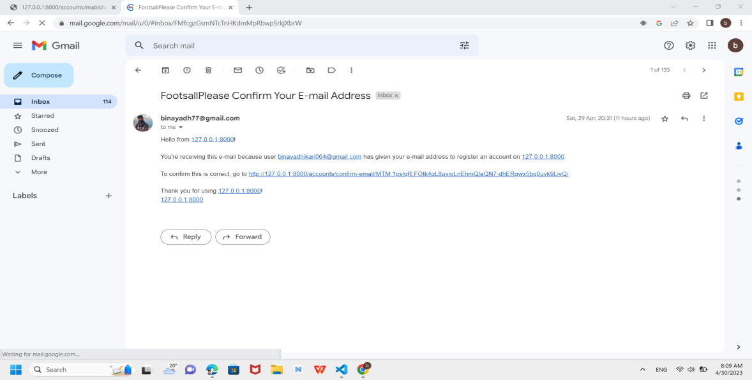

Email Validation & user conformation.

**Tie-sheets:**

